1. BACKGROUND AND EVENT

import pygame

pygame.init()

# background/screen

screen_width = 626

screen_height = 417

display_output = [screen_width,screen_height]

screen = pygame.display.set_mode((display_output),pygame.RESIZABLE)

background = pygame.image.load('images/bg_1.jpg').convert()

# display name

pygame.display.set_caption("Collect the Trash")

play = True

# 1 event screen/play

def check_for_event():

global play

for event in pygame.event.get():

if event.type == pygame.QUIT:

play = False

while play:

screen.blit(background,(0,0))

check_for_event()

pygame.display.flip()

pygame.quit()

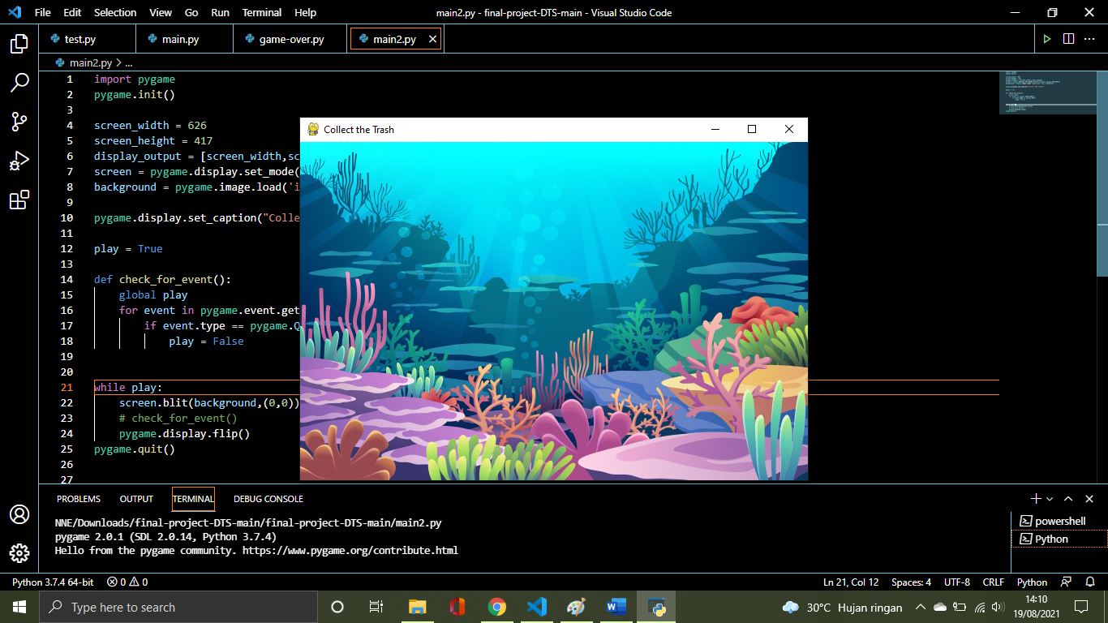

1. INITIALIZED PLASTIC AND PUT RANDOM IN SCREEN WIDTH

another text..

from random import randint

another text..

plastic = pygame.image.load('images/plastic_raw.png').convert_alpha()

x = randint(0, screen_width)

y = 0

radius = 35 # plastic width

plastic_rep_x = x + 50 # keep the plastic in range x

plastic_rep_y = y + 50 # keep the p;astic in range y

another text..

def show_images():

    screen.blit(plastic, (x,y))

loop play

while play:

    screen.blit(background,(0,0))

    check_for_event()

    show_images()

    pygame.display.flip()

pygame.quit()

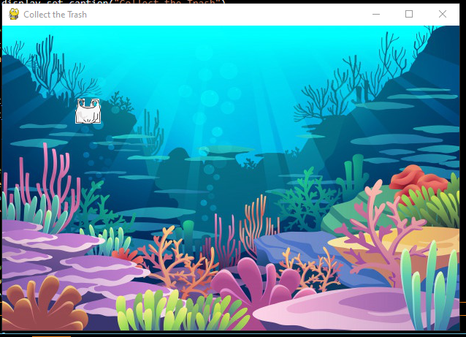

1. INITIALIZED PLASTIC FALL

Initialized speed

speed = 5

function position plastic

def update_pos_plastic():

    global y, plastic_rep_x, plastic_rep_y

    y += speed

    plastic_rep_x = x + 50

    plastic_rep_y = y + 50

loop play

while play:

    screen.blit(background,(0,0))

    check_for_event()

    update_pos_plastic()

    show_images_plastic()

    pygame.display.flip()

pygame.quit()

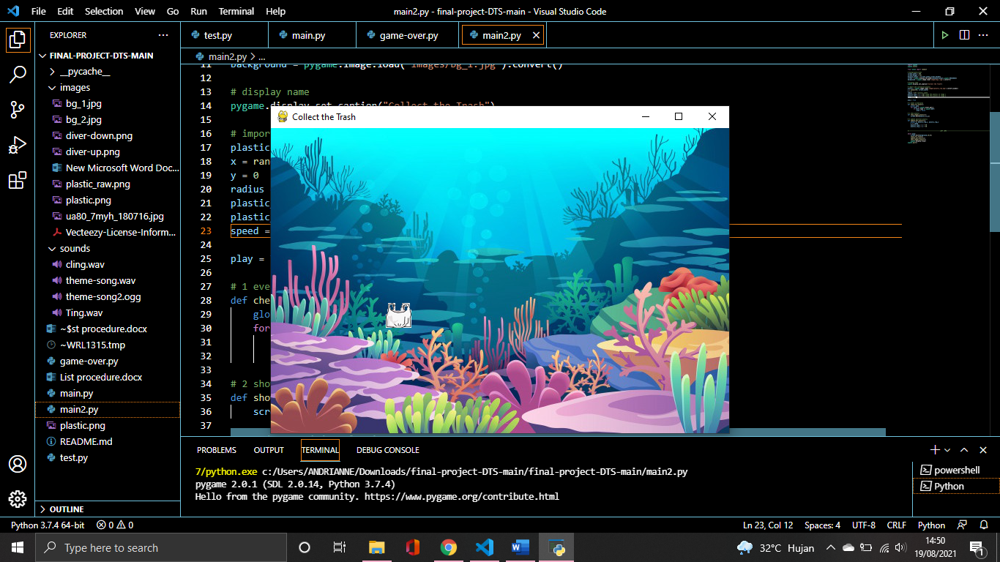

1. SET THE CLOCK SO PLASTIC FALL SLOW DOWN

Set the clock

clock = pygame.time.Clock()

loop play

while play:

    clock.tick(60) #set 60

    screen.blit(background,(0,0))

    check_for_event()

    update_pos_plastic()

    show_images_plastic()

    pygame.display.flip()

pygame.quit()

1. INITIALIZES PLASTIC POSITION AND ADDING BORDER

Initialise new random plastic down

def initialise_plastic():

    global x, y

    if y > screen_height - radius:

        y = 0

        x = randint(0, screen_width)

call the function after update_position_plastic

def update_pos_plastic():

def update_pos_plastic():

    global y, plastic_rep_x, plastic_rep_y

    y += speed

    plastic_rep_x = x + 50

    plastic_rep_y = y + 50

    initialise_plastic()

call enforce border into loop play

while play:

    clock.tick(60)

    screen.blit(background,(0,0))

    check_for_event()

    update_pos_plastic()

    enforce_border()

    show_images_plastic()

    pygame.display.flip()

pygame.quit()

1. IMPORT PLAYER AND POSITION

Import images and initialize position and region player

player = pygame.image.load("images/diver2.png").convert_alpha()

player_width = 175

player_pos_x = 200

player_pos_y = 450

player_speed = 8

player_rep_x = [player_pos_x + 31, player_pos_x + 94] # region to score

player_rep_y = [player_pos_y + 14, player_pos_y + 20] #region to score

call player into show_images function

def show_images():

    screen.blit(plastic,(x,y))

    screen.blit(player, (player_pos_x, player_pos_y))

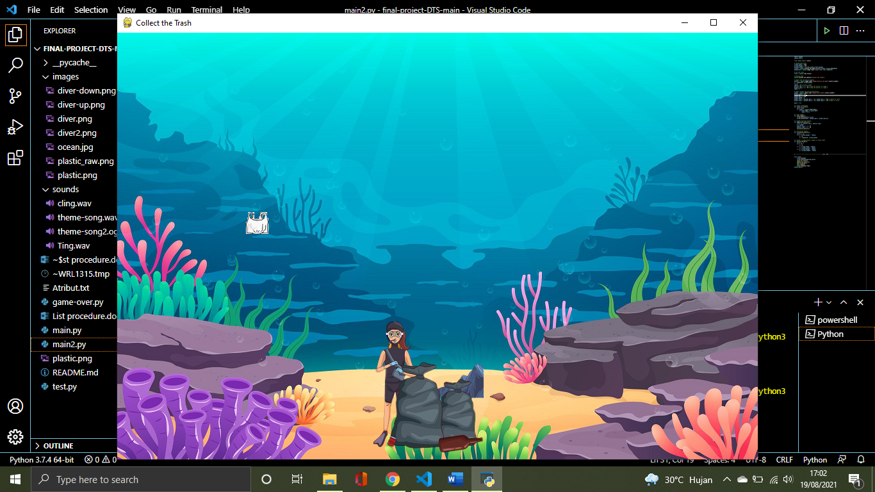

1. MAKE THE DIVER SLIDE RIGHT-LEFT

With Left and Right Keys, move the player to the left or right

def check_for_event():

    global play, player_pos_x, player_pos_y

    for event in pygame.event.get():

        if event.type == pygame.QUIT:

            play = False

    keys = pygame.key.get_pressed()

    if keys[pygame.K_LEFT]:

        player_pos_x -= player_speed

    if keys[pygame.K_RIGHT]:

        player_pos_x += player_speed

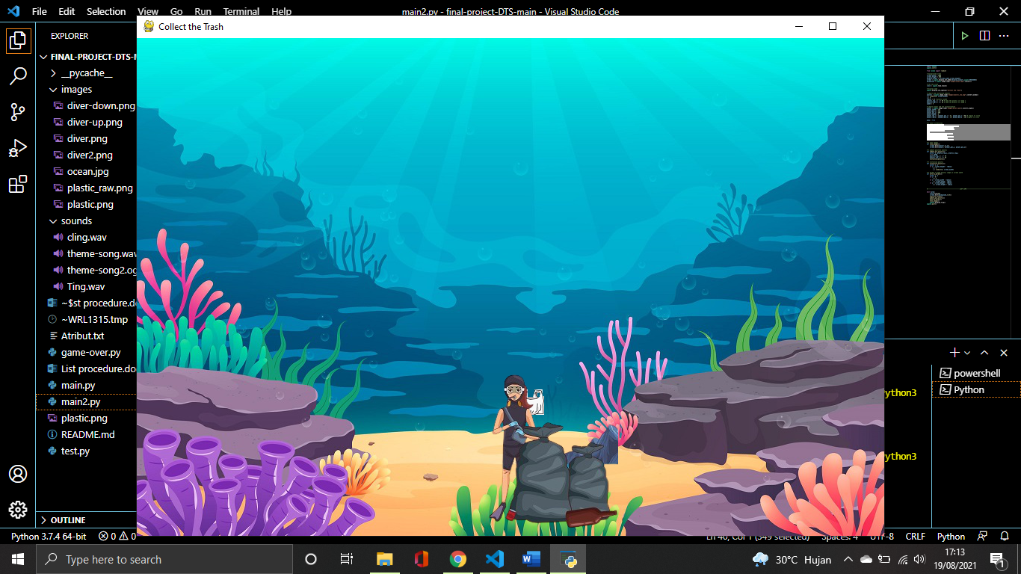

1. BORDER FOR DIVER

Add code into enforce_border, if the player less than or more than screen width

def enforce_border():

    global x, y, player_pos_x, player_pos_y

    if x < 0:

        x = 0

    if x > screen_width - radius:

        x = screen_width - radius

    if y > screen_height - radius:

        y = screen_height - radius

    if player_pos_x < 0:

        player_pos_x = 0

    if player_pos_x > screen_width - player_width:

        player_pos_x = screen_width - player_width

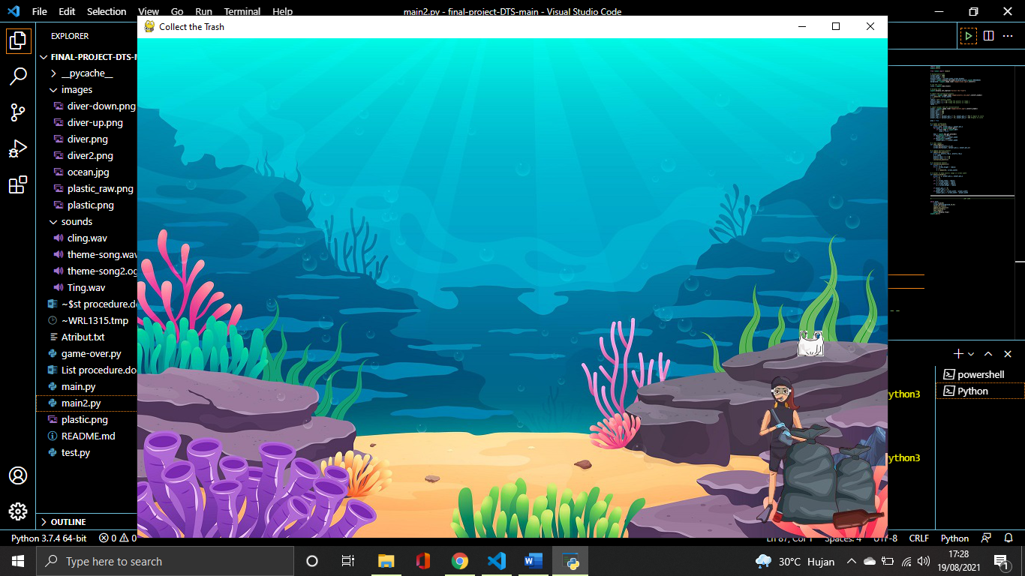

1. COUNT SCORE OR RESET SCORE

Add function to declare plastic fall into player region

def check_for_score():

    global score

    if plastic_rep_x in range(player_rep_x[0], player_rep_x[1]) and plastic_rep_y in range (player_rep_y[0], player_rep_y[1]):

        score += 1

    elif plastic_rep_y in range(player_rep_y[0], player_rep_y[1]) and plastic_rep_x in range (player_rep_x[0], player_rep_x[1]):

        score = 0

show score

def show_score():

    print(score)

Output print score

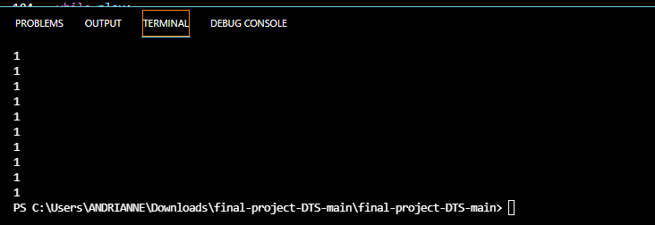

1. DISPLAY SCORE

Initialization text score

black = (0, 0, 0)

text_x = 15

text_y = 15

font = pygame.font.Font("freesansbold.ttf", 40)

Add code into show_score function

def show_score():

    score_display = font.render("Score " + str(score), True, black)

    screen.blit(score_display, (text_x, text_y))

Call function in loop play

while play:

    clock.tick(60)

    screen.blit(background,(0,0))

    check_for_event()

    update_pos_plastic()

    enforce_border()

    show_images()

    check_for_score()

    show_score()

    pygame.display.flip()

pygame.quit()

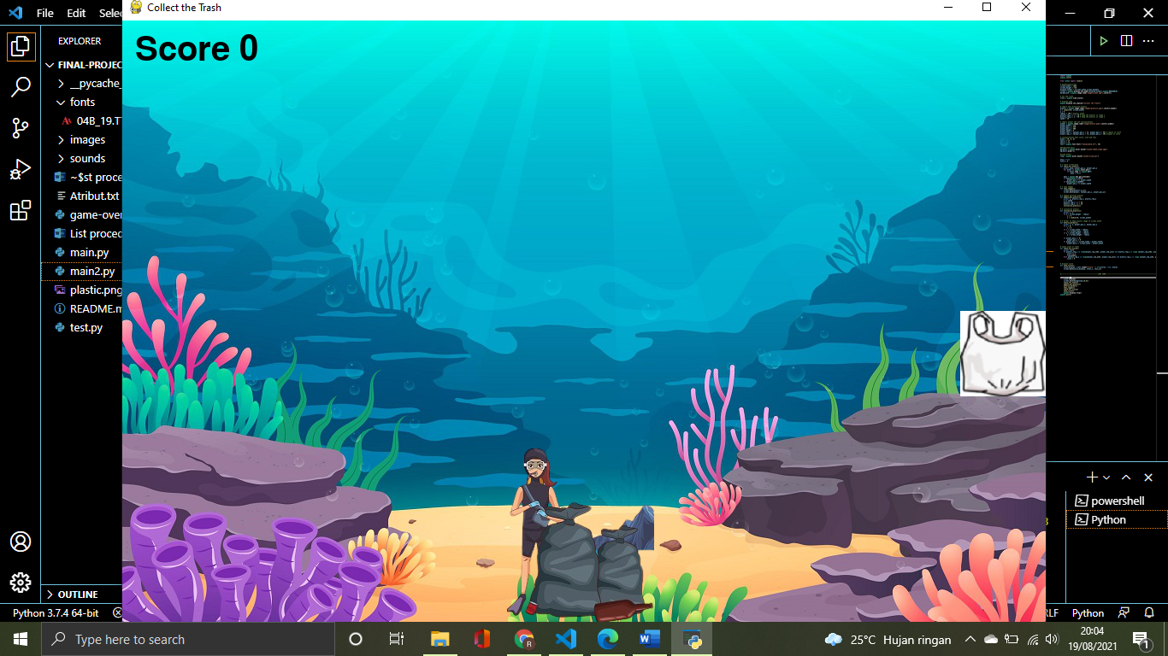

1. ADD SOUND THEME AND SOUND EFFECT

Initialization background music and sound effect

bg_music = pygame.mixer.Sound("sounds/theme-song2.ogg")

bg_music.play(-1)

ting = pygame.mixer.Sound("sounds/cling.wav")

Add code into check_for_score funtion

def check_for_score():

    global score

    if plastic_rep_x in range(player_rep_x[0], player_rep_x[1]) and plastic_rep_y in range(player_rep_y[0], player_rep_y[1]):

        score += 1

        ting.play() #sound effect

    elif plastic_rep_y in range(player_rep_y[0], player_rep_y[1]) and plastic_rep_y not in range(player_rep_x[0], player_rep_x[1]):

        score = 0